**Motion capture data processing and analysis**

Table of Contents

List of Abbreviations - 0 -

1 Introduction - 1 -

2 Theory. Analysis. Aim. - 2 -

2.1 Motion Capture - 2 -

2.1.1 History of motion capture - 2 -

2.1.2 Optical-based motion capture system VICON - 3 -

2.2 Sign language analysis - 5 -

2.2.1 Hamburg Notation System - 6 -

2.3 Optical-based motion capture for sign language synthesis - 12 -

2.4 Segmentation of SL - 12 -

2.4.1 Method for segmentation - 13 -

2.4.2 Conclusion - 13 -

2.5 Conclusion - 14 -

3 System Architecture - 15 -

3.1 Python - 15 -

3.1.1 NumPy (Commits: 15980, Contributors: 522) - 15 -

3.1.2 SciPy (Commits: 17213, Contributors: 489) - 16 -

3.1.3 Matplotlib (Commits: 21754, Contributors: 588) - 16 -

3.2 data format (.c3d) - 17 -

3.3 methods for segmentation and it is challenges - 17 -

3.4 problems with acceleration computation // fuzziness - 17 -

3.5 methods for filtering - 17 -

3.6 methods used for describing the properties of each sign - 17 -

3.7 SVM - 17 -

4 Testing - 18 -

5 Conclusion - 19 -

6 Bibliography - 1 -

Table of Figures

Figure 1: "The horse of motion" by Eadwerd Muybridge - 2 -

Figure 2: General structure of HamNoSys notation - 6 -

Figure 3: Handshapes - 7 -

Figure 4: Wrist bending - 7 -

Figure 5: Extended finger orientation and Palm orientation - 8 -

Figure 6: Body parts - 9 -

Figure 7: Six zones of signing space and their symbols - 9 -

# List of Abbreviations

3D Three-dimensional

MoCap Motion Capture

fps frames per second

SL Sign language

HamNoSys Hamburg Notation System

RP Rest Pose

# Introduction

Motion capturing is a modern, fast developing data acquiring method capable to record movement in 3D. The detailed data that is retrieved from such recording is very useful not only for movie and game industry, but also in other fields as military, medicine and for validation and control of computer vision and robotics. The benefits of this method attract scientist to utilize it for linguistic analysis. Sign language is the primary alternative to a spoken language. Unfortunately, there are people for whom this is the only alternative that gives them the ability to communicate and share thoughts directly. Sign language uses manual movements and body language to communicate thoughts with others. The basic component of a sign language includes hand gestures, movements, orientation of fingers and hands, hand shapes and facial expressions to communicate certain feelings. Every region in the world has a unique spoken language and similarly, every region has a unique sign language. Thus, sign language varies from culture to culture and from region to region. People with speech and/or hearing impairment find it difficult to communicate with other individuals via sign language due to the inability of most of the people to understand sign language.

The purpose of this paper is to show the methods of studying and understanding the properties of signs from motion point of view and developing a tool for processing sign language data base. It is focused on hand movement and gestures analysis. It is cultural and regional independent, because it uses kinematic and statistical methods for processing the data.

Such database is set of dictionary (lexical items separated by default stance //not sure if it should be here or later in the main part) files with motion capture data. The tool will perform raw segmentation (in the first step) and fine segmentation (using acquired parameters from data) of dictionary items to extract the meaningful information for each sign which will be used for further analysis. It will show the challenges to determine the exact beginning and ending of the sign. The significant problem with the nature of the data – the containing of noise and methods for isolating that noise. Each sign will be processed for extracting its properties. Such as: if the sign is one handed or two, which is the dominant hand, hand location and orientation, finger orientation.

Later with the help of computer learning methods such as SVM the extracted information will be used to cluster signs for further processing.

# Theory. Analysis. Aim.

## Motion Capture

### History of motion capture

In general, the term motion capture (MoCap) is understood as the process of recording the movement of object, people or even animals. It is not specifically related to any device or approach. Today’s motion capture systems are product of many years of tinkering and innovation.

At the beginning MoCap analysis originate as gait analysis and animal locomotion around the year of 1872 and work of the photographer Eadwerd Muybridge. He used multiple cameras, triggered by strings to take pictures of moving bodies and animals. Capturing what human eye could not distinguish as a separate movement. His work “The horse in motion” was the first work recognized as a motion capture analysis. With a series of photographs of a galloping horse (see figure 1) he proves that horses do have all four hooves of the ground during their running stride [[3](Muybridge's#_E._Muybridge,_)].

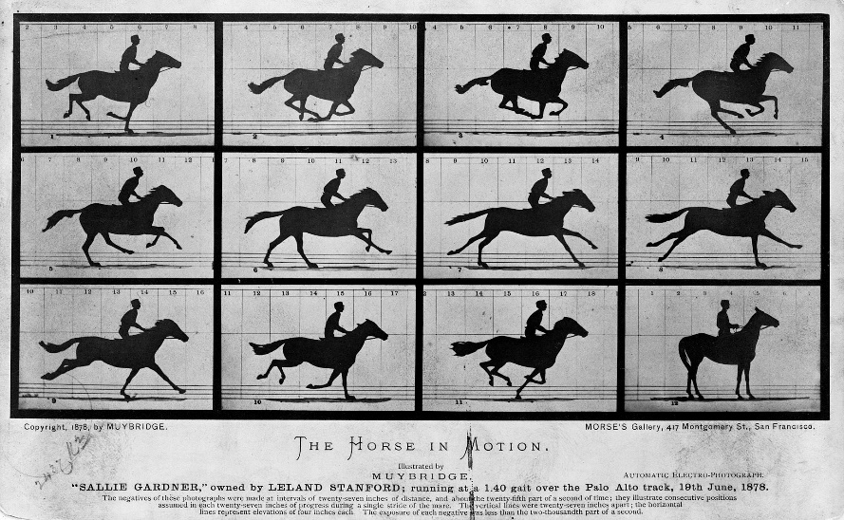

Figure 1: "The horse of motion" by Eadwerd Muybridge

Since then the technology has developed to the form of devices designed for direct 3D recording. The biggest success and from where it gains its popularity is the usage in the movie industry. The first fully digital created character with the help of MoCap technique was Jar Jar Binks performed by Ahmed Best in Georges Lucas’ Star Wars Saga in 1990.

~~The usage of this techniques has expanded over the entertainment industry to sport industry, medicine and robotics. This leading to developing of different, more accurate and at the same time more affordable for wider use devices~~

Motion capturing started as biomechanics research tool, gained its popularity with its usage in entertainment industry and expanded into education, training, sports, and robotics.

There are different approaches to motion capture. Every system has its advantages and disadvantages. ~~Non-optical systems – Mechanical, Inertial and Magnetic. Optical systems are markerless, optical-passive and optical-active.~~ Optical passive system is considered as the most accurate and flexible technique and thus most common in the industry.

~~2.1.1 Markerless - This technique does not require markers to be worn and instead relies on software to track the subjects' movement. Varying tracking methods yield different results, but real-time and final data error ranges tend to be larger than marker-based solutions.~~

~~2.1.2 Inertial - This technique does not require cameras except as a localization tool. Inertial sensors are worn by the subject and the data from the sensors is transmitted wirelessly to a computer.~~

~~There are two variants of optical systems that use markers. The active optical system uses cameras that work in visible spectrum and markers in form of Light-Emitting Diodes (LED). The need of power source for each marker may be considered as disadvantage. Presence of wires may affect movements and their measurement. On the other hand, markers can be distinct easier during tracking, because LEDs use different wave length.~~

~~Usually cameras for MoCap systems work in infra-red spectrum and use markers coated with retroreflective material, also called passive markers. As disadvantage of this approach may be considered the need of external light at the scene. Often the external source of light is part of the camera’s body. Passive markers may be attached directly to the performer skin (in case of facial motion capture) or clothes. This method is considered as the most flexible and common type of MoCap.~~

### Optical-based motion capture system VICON

Motion capture technology was used to generate data files for both continuous and isolated utterances. The data used for this project was recorded at the University of West Bohemia with MX series device from VICON [6]. This is an overview of the basic principle of the technology on which the system is based. This system is based on optical- passive technology and was chosen for the sign language project because it suits the best for the purposes of the project.

The technology provides accurate data at fast sampling rates, and the same system can be used to capture the motion of a wide range of structures, including objects, animals, human bodies, fingers and faces. By using passive (reflective) markers, all processing is done externally, and the captured subject does not need to wear electrical equipment or wires. Which is advantage in capturing finger motion, because the presence of wires can impede the naturalness of movements. The system is comprised of eight specialized infra-red cameras along with computers and software for image analysis and processing. The cameras detect small markers placed on strategic locations on the captured subjects. On figure 2 can be seen the general marker placement for human body. In this case passive markers are used, they are coated with retroreflective material, and this requires the cameras to emit the light, which is reflected back and detected. The external source of light is part of the camera’s body.

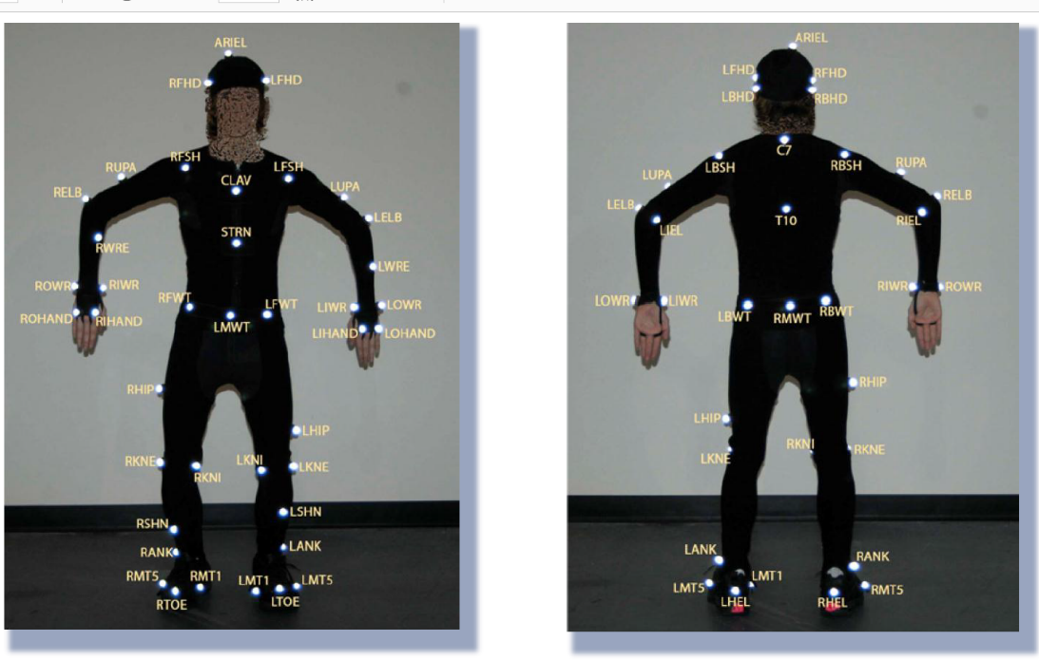

Figure 2: General marker set for human body

The detected information is then processed in dedicated hardware using software provided by the manufacturer to triangulate the 3D locations of the markers. The exact process and algorithms are know-how of devices’ manufacturer, but it is based on stereoscopic vision.

After reconstructing the 3D points into a point cloud, the system needs to determine which point is which and label each point with a marker id. This process is commonly referred to as marker labelling. The marker data is then used to estimate the kinematic motion of a model of a human skeleton. The estimation in form of bone lengths and joint angles can be used for further processing or animation. This process is called solving. The mentioned software is able to provide semi-automatic calibration of human subject for general movement.

Although this technology comes with highly accurate results and it is very flexible there are some disadvantages which may result in poor data quality or extensive costs in manual post-processing. As every vision-based technology it needs clear line of sight and occlusions may cause serious challenges. Markers placed on fingers are especially problematic and often suffer from self-occlusions when the fingers are bent or the hands are facing towards the body or with palm-up [5]. Occlusions do not only cause problems with missing data, they also make the labeling process more difficult as this reduces the available information for inference. Further challenges arise in situations when several markers come in close contact (such as clapping hands).

To summarize, optical motion capture provides highly accurate data, but may require a large amount of manual post-processing.

## Sign language analysis

Sign language is used by millions of people around the world. It is used to facilitate communications with people with speech or hearing impairments. There are different sing languages as there are different spoken languages. Also there is common misconception that sign language is dependent on spoken language, that it is spoken language expressed in signs [8]. Linguists has studied and proved that sign languages exhibit the fundamental properties that exist in all languages and there are similarities between both forms, but there are some basic differences. The linguistic mechanism in both is different and therefore it causes difficulties for people with such impairments, especially for those who are born this way, to use even the written form of a spoken language [9]. In spoken language units are organized sequentially (it is not possible to say two different words at the same time), but in sign language the meaning of one unit may be carried by the shape of the hands and their position or/and by the position and movement of head and mimics. These two components can be carried simultaneously.

All these circumstances not only put a communication barrier between people using sign language and majority of hearing community, but also restrict them from most sources of information. Another difference between both is sign languages does not have its own system. This led scientist to develop writing system to represent signs. The pioneer in sign language analysis was W. Stoke. As it is explained in M. Kato paper [[3](A#_Mihoko_Kato,_)] Stoke proves that each sign in American sign language has tree elements that distinguish it from all other signs:

1. Hand Configuration (the distinctive configuration of the hand or hands making a sign),
2. Place of Articulation (the place where a sign is made),
3. Movement (the action of the hand or hands).

Stokoe decided to call the active hand the “designator” or “dez”; the place, the “tabula” or “tab”; and the action, the “signation” or “sig.” A sign is produced by a combination of these three aspects.

Nowadays most of the notion systems for sign languages are based on his study and notion system.

### Hamburg Notation System

Such system is the Hamburg Notation System (HamNoSys) [[1](Hamnosys-representing#_T._Hanke,_)]. It is a work of scientists from University of Hamburg. It is an alphabetic system that decompose signs to phonetic level and describes their sub lexical parameters location, configuration and movement. It is based on Stokoe’s notation system [2]. It is designed to be usable in variety of context with the following goals in mind:

* International use - HamNoSys transcriptions to be possible for virtually all sign languages in the world.
* Iconicity – because of the large number of parameters variations, newly created glyphs should be designed to be easy to memorize or even deduct the meaning
* Economy – notation of signs should make use of principles as symmetry conditions, thus resulting in shorter notions.
* Integration with standard computer tools – It should be usable for computer –supported transcription, standard text processing and database applications.
* Formal syntax – The notation language should have well-defined syntax.
* Extensibility – As SLs are developing and differ from each other, HamNoSys should allow both for a general evolution and specializations. [[1](Hamnosys-representing#_T._Hanke,_)]

Because of all described goals of HamNoSys it seems that it is preferred from scientific community working in the domain of language analysis and synthesis, although it is not very accepted from deaf community.

This notation system was chosen for sign language project because it suits the best for its purposes. I used it as guidelines in my work for describing the properties of signs from motion point of view.

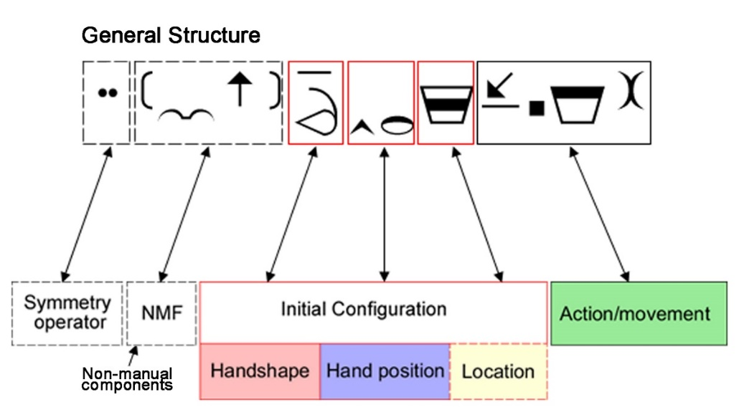

Figure 3: General structure of HamNoSys notation

In general, a sign notation consists of description of non-manual features, handshape, hand orientation and location, plus the actions changing this posture. If the sign is two handed at the beginning of notation is added an operator to show how the description of dominant hand is copied to the non-dominant hand. The signs are realized in signing space and terms expressing directions are determined from the signer’s perspective. Figure 3 shows example of sign notation and its general structure with its mandatory (the ones with solid border) and optional components (boxes with dashed border).

#### Handshapes

Handshape is expressed by symbols for basic forms – **Fist, Flat hand, Separated fingers, Thumb combination** and bending (see Figure 4)

The configuration of the thumb alters the structural arrangement of the entire hand and thereby define a new group of handshapes, where shapes are derived from other basic shapes.

In addition to the general description of the sign, information for different fingers and finger parts (in respect to the fingers involved), may be included.

Figure 4: Handshapes

#### Hand orientation

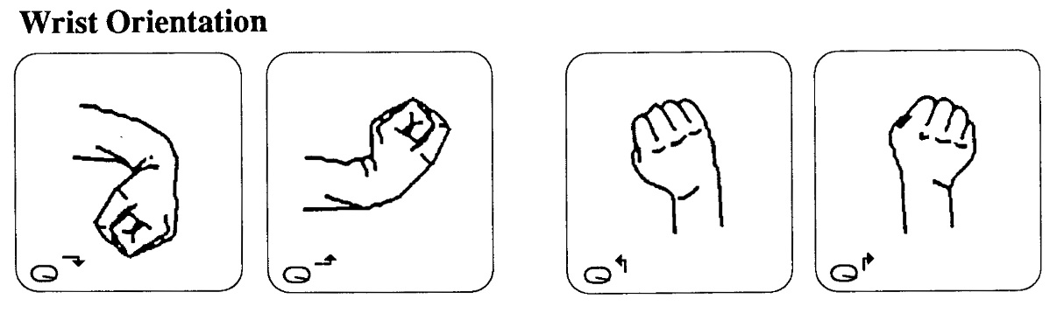The orientation of hand is described by **Wrist orientation, Extended finger and Palm orientation**. Where wrist orientation is characterized by bending of the wrist toward the pulse or back of the arm, toward the thumb or little finger (see Figure 5). It is omitted when the bending is natural consequence of palm orientation with movement.

Figure 5: Wrist bending

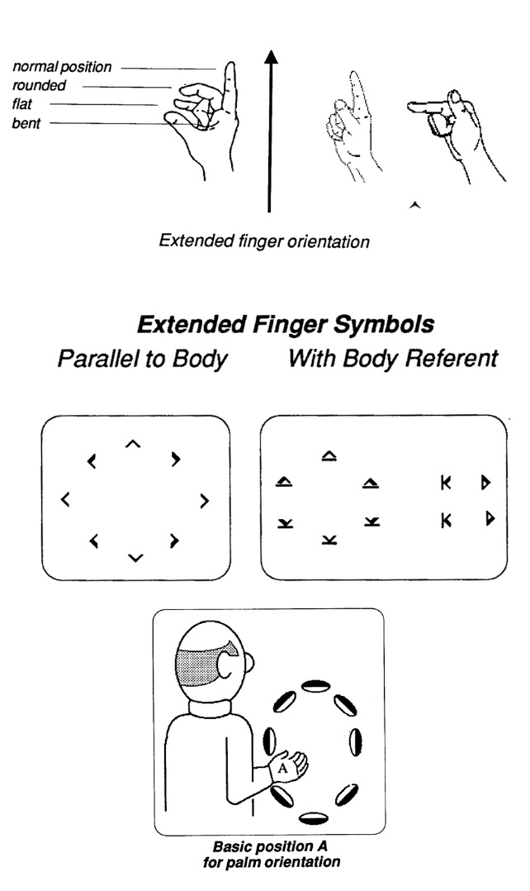The vector originating at wrist, running along the back of the hand and pointing to the direction pointed by the fully extended finger, shows the orientation of the Extended finger. This orientation may be difficult to be defined when all fingers are bend in some way. As it can be seen on Figure 4, the two hand shapes on the right are noted with same symbol. Fingers point in different direction, but the base of the finger (knuckle) points in the same. If finger orientation is not parallel to the body plane, the notation must contain the body referent symbol (Figure 4).

Palm orientation is always noted after the Wrist and Extended finger orientations are. To define it, first Basic Position of the palm must be determined, then the orientation is determined by the orientation of the palm around the shaft of the hand (Figure 6, bottom). There two Basic Positions. When finger orientation is away from the body is Basic Position A, otherwise is Basic Position B.

Figure 6: Extended finger orientation and Palm orientation

#### Hand location

Hand location is noted only if it is very specific on the body or in the signing space. If not noted it is understood that sign takes place in the natural space, in front of the upper part of the body. There are different sets of location signs. One is expressing locations on body (Figure 7), another one describes relative position to the body part. Figure 8 shows the division of the signing space into six horizontal zones, each zone is noted with different symbol. In two-handed signs location information concerning hands and arms, refers to locations on non-dominant hand and characterize the relation between the two hands. Again all determinations of left and right are made from signer’s point of view.

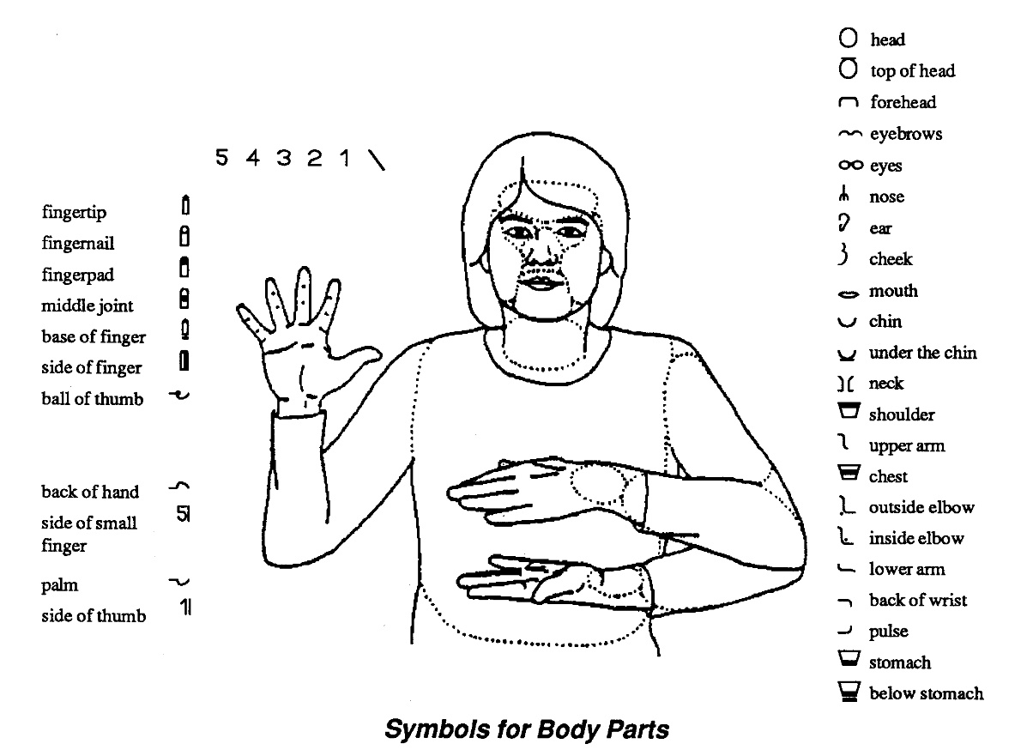

Figure 7: Body parts

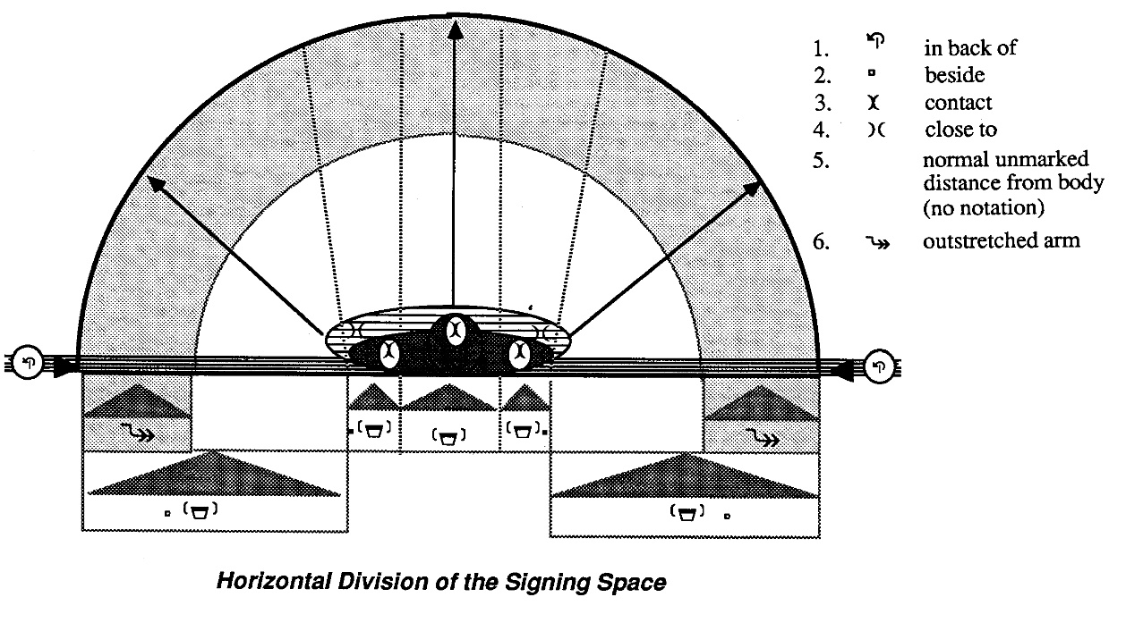

Figure 8: Six zones of signing space and their symbols

#### Movement

There are few aspects of the movement that have to be considered when describing movement in signs: **Movement type, Manner of movement, Repetitions, Order of movement symbols**. The distinguished types of movement are: straight, curved, wavy, zigzag, circular and spiral.

The manner of movement aims do describe size, speed and intensity of the movement. There are three degrees of size: large, normal and small and only large and small size are explicitly notated. The speed and intensity are described as: fast movement, slow movement, tense, hold or rest (usually on onset or offset of the movement), abrupt halt at the end of the movement.

Two types of repetitions are distinguished. Ones which lead back to the beginning of the movement and those whose initial position continuously change. The number of repetitions is indicated by the number of repeating symbols.

The order of notation of these aspects is strongly defined as follows:

1. Circling movement or direct movement
2. Type of movement:
3. Manner of movement
4. Repetition

#### Two handed signs

Two handed signs are divided into symmetrical and nonsymmetrical signs. In the symmetrical ones both hands show the same handshape and therefore only the dominant hand is notated. But the coordination of both hands should be noted either as mirrored or parallel. Also should be noted if the movement in both hands occurs simultaneously or alternately. In case of nonsymmetrical signs, the movement occurs only with the dominant hand and the handshapes are often different, therefore notation for both hands is needed. Always the notation of the dominant hand should precede the non-dominant.

#### Conclusion

Sign language and spoken language developed separately and this led to different linguistic structures, restricting people with haring and speaking impairments from vast information and free communication. Linguist have been working on developing good sign representation as it is important from many aspects. Although it is not very accepted by deaf community, because of its complexity, the Hamburg Notation System seems to be a good choice for representing signs in computer, as it was developed with the idea to be available for international use and easy for computer implementation.

## Optical-based motion capture for sign language synthesis

There have been several research projects for developing assistive technology for Deaf population. They are based on different techniques, such as key frame techniques and procedural synthesis. As it is explained in [13] they allow fine control over the movement of the signing avatar, but it might be poorly accepted by people, because of lack of human-like movements. Scientists as McDonald et al [4] work on resolving this problem by analyzing noise in motion capture data and adding the human-specific noise in the key-frame driven motion. Other approach is data-driven synthesis. When used with MoCap data from real signer the motion is preserved and therefore the animation is more human-like.

On the other hand, this approach needs a rich MoCap dataset for sign language, which faces other challenges. As mentioned before SL is a complex composition of simultaneously movements of different parts of human body. The difficulty is to record and synchronize all these components, because every utterance can be done with time and special variance even if performed by one signer. At university of West Bohemia face this problem by using the state-of-the-art device for motion capturing [12]. The system they use is combination of different cameras and retro-reflexive markers with different sizes for different body parts. As this is a new approach, the data set is not that rich yet.

Datasets for SL may differ in their content. Some contain isolated utterances other whole sentences or phrases with continuous utterances. For the purpose of my work I have used the dataset with isolated utterance.

## Segmentation of SL

The benefits of data-driven methods for SL synthesis were discussed in the previous section, but in order to have good and valid results the data must reliable. Before proceeding to any kind of analysis the data need to be structured in forms that suits the final purposes

Segmentation is the process of breaking a continuous sequence of movement data into smaller and meaningful components. The process consists of determining the exact beginning and ending frames of this meaningful component. Identifying of segments is challenging task due to multidimensional nature of SL.

There is a study over French sign language [13] which is based on manually annotated data, segmentation is performed by expert annotators (deaf signers). As it is explained in the paper manual segmentation and annotation is laborious and time-consuming process. Identifying the exact start and end frame made by human is subject to variability, even if made by experts. The focus of this study is transition movement. This is movement have no linguistic meaning but it is important for making the animation more human-like.

There are several studies researching the issue of segmentation, but as far as I am aware, there still have not been developed a fully automatic segmentation of continuous utterance with good precision. The approach for identifying segment boundaries by detecting changes in kinematic features for general motion and in the case of isolated utterance seems to be promising.

### Method for segmentation

In my work the segmentation is designed to be made over sets of isolated utterance and is done in two steps. In these data sets signs are separated with one exact pose – rest-pose (RP). The identification of segments is based on kinematic analysis of hands movement.

At first step start and end tag define these frames where hands leave and enter, respectively, rest pose. Knowing this frames helps me to analyze hands behavior during rest pose and thus refine threshold variables for finer segmentation on next step.

At second step the frames that I am interested in are those where the meaningful part of sign begins and ends. Meaningful part is the one that have linguistic meaning and is described by HamNoSys notation. This motion subsequence will be further analyzed.

The main idea behind kinematic analysis is that significant changes in trajectory of a hand can be indicated by changes in velocity and acceleration. Human body is not a simple mechanism and in order for the hand to perform a movement it needs preparation and this can be seen from hand velocity and acceleration.

### Conclusion

In this paper SL is reviewed as continuous stream of motion, with no consideration of linguistic meaning of the signs. My purpose is to extract the properties of each sign based on HamNoSys notation (described in section 2.2.1). But in order to have valid results I had to do proper segmentation, to extract the meaningful parts from long stream of data. To achieve that I analyzed the kinematics of the motion as position, velocity and acceleration.

## Conclusion

Sing language is important for certain part of our community. It is complex and by its nature very different of the spoken language that most of us are familiar with. There have been different researches and projects for developing signing avatar with increasing quality over time. New approaches include data-driven methods, using devices for recording 3D movements in order to save human-like motion. But the issue of automatic processing and computer understanding are still challenging tasks. My purpose is to develop a tool helping dealing with such issues.

# System Architecture

After analyzing the theory behind motion capture technology, sign language and its properties and different approaches for sign language synthesis is possible to proceed with actual describing of the system’s architecture. The tool will perform two step segmentation over input data. The input data is long stream of 3D recorded signs performed by professional signer. After that the motion data will be analyzed to extract motion features of each sign.

## Python

Python is a high-level, interpreted and general-purpose dynamic programming language that focuses on code readability. The syntax in Python helps the programmers to do coding in fewer steps as compared to other programming languages. It is very flexible language supporting multiple programming paradigms, including object-oriented, imperative, functional and procedural. It has a large and comprehensive standard library that has automatic memory management and dynamic features. The programmers of big companies use Python as it has created a mark for itself in the software development with characteristic features like-

* Interactive
* Interpreted
* Modular
* Dynamic
* Object-oriented
* Portable
* High level
* Extensible in C++ & C

One of its biggest advantages is its Extensive Support Libraries that include wide range of areas such as string operations, Internet, web service tools, operating system interfaces, protocols, data-analysis and more. These libraries make Python more useful for specific purposes. Additionally, Python has become a go-to language for data analysis. With data-focused libraries like NumPy, and matplotlib, making it powerful tool for processing, manipulating, and visualizing data [14].

### **NumPy**

The most fundamental package, around which the scientific computation stack is built, is NumPy (stands for Numerical Python). It provides an abundance of useful features for operations on n-arrays and matrices in Python. The library provides vectorization of mathematical operations on the NumPy array type, which ameliorates performance and accordingly speeds up the execution.

### SciPy

SciPy is a collection of mathematical algorithms and convenience functions built on the NumPy extension of Python. Its different submodules correspond to different applications, such as interpolation, integration, optimization, image processing, statistics, special functions, etc.

### Matplotlib

Another SciPy Stack core package and another Python Library that is tailored for the generation of simple and powerful visualizations with ease is Matplotlib. It is a top-notch piece of software which is making Python (with some help of NumPy, SciPy) a cognizant competitor to such scientific tools as MatLab or Mathematica.

However, the library is pretty low-level, but with a bit of effort, you can make just about any visualizations:

* Line plots;
* Scatter plots;
* Bar charts and Histograms;
* Pie charts;
* Stem plots;
* Contour plots;
* Quiver plots;
* Spectrograms.

There are also facilities for creating labels, grids, legends, and many other formatting entities with Matplotlib. Basically, everything is customizable.

### C3D

This is a small library for reading and writing C3D binary files. C3D files are a standard format for recording 3-dimensional time sequence data, especially data recorded by a 3D motion tracking apparatus.

## Sublime Text code editor

Sublime Text 3 is a lightweight, cross-platform code editor known for its speed, ease of use, and strong community support. It’s an incredible editor right out of the box, but the real power comes from the ability to enhance its functionality using Package Control and creating custom settings. There are many plug-ins accessible that make Python development extremely smooth and pleasant.

**Anaconda** is an extremely powerful Python package for Sublime. It offers:

* Python code auto completion
* Python lining (highlights both syntax errors and PEP8 violations)
* Python documentation

## C3D file format

C3D is a biomechanics and motion capture file format. It stores raw 3D coordinates and analog sample data, together with information that describes the stored data. The C3D format treats information as if it belongs to one of two classes: **Physical Measurements, Parameter Information**.

Physical Measurements - The C3D specification expects physical measurements to be one of two types, either positional information (3D coordinates) or numeric data (analog information).

Parameter Information - contain information about the data such as measurement units and data point labels, database information such as the subjects name, diagnosis and other items that may be specific.[15]

For this project C3D file format is used for the input data. It contains the raw output data of the MoCap system.

## Activity flow

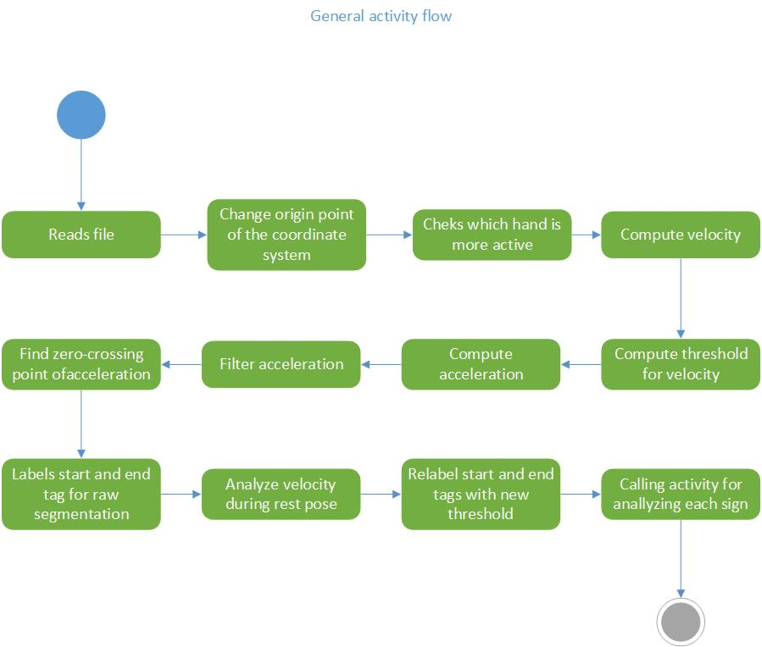The dynamic behavior of the system is shown in the following UML activity diagrams.

Figure 9: General activity diagram

The general activity flow of the system is shown on Figure 9. First the input file is read and the information about markers positions is stored in multidimensional array (in form of: for each frame, for each marker, x ,y ,z, coordinates). Other extracted information is the frame rate and the set of labels of used markers (in an list structure). The last element of the list of markers is additionally added marker for the origin of the coordinate system.

Next activity is to check which hand is more active. The further analysis is performed over the movement of the dominant hand.

Next step is to recalculate 3D coordinates for each frame so that the center of the coordinate system to be in the middle of the body. This is done in order to make further calculations independent of the signer’s physicals characteristics or his position in the scene.

After that the system computes hands velocity and acceleration. Because I am interested in the general motion of the hand, not the movement in the tree channels, acceleration is computed over the normalized velocity.

A crucial step in the processing of the data is the use of low pass filtering to eliminate jitter in the acceleration. It is important because of the next step – finding the zero-crossing points. If the function is too noisy there might be found false points. On the other hand filtering cause lost of information and thus missing important points. As explained earlier the sudden changes in velocity indicates changes in trajectory. Therefore this points are matter of interest, they can indicate a start or end of a sign.

Next step is called labeling. It uses a threshold function to filter the set of zero-crossing points. The result at the end of this step is list of start and end frames for the raw segmentation.

Knowing this start and end tags, gives me the opportunity to analyze hand velocity during rest-pose and this way to choose better value for the threshold function.

Next step is just redoing the labeling with the new threshold value.

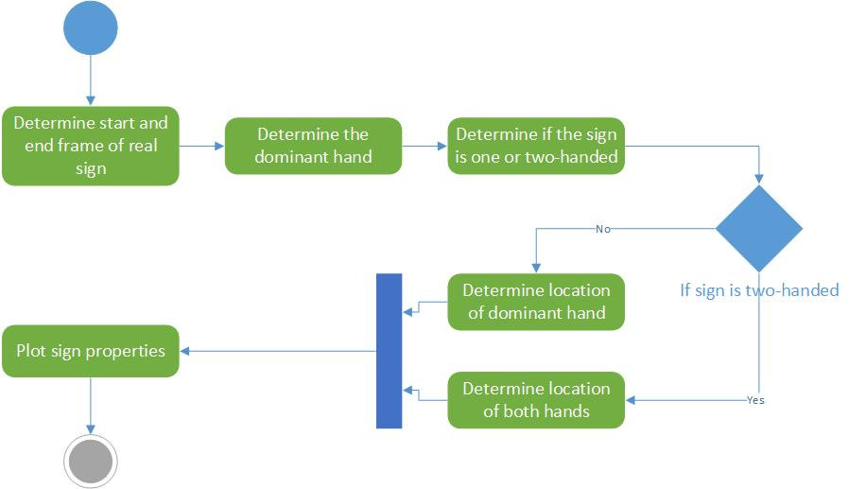

Figure 10:Sign analysis

Figure 10 shows the flow activity during analysis of the segmented data. First is determined the exact start and end frame of the real sign (the explanation what exactly is the real sign is given in section 2.4). By comparing hand displacement of left and right hand can be determined the dominant hand and if the sign is one or two-handed. Based on this knowledge I hand location can be examined (this is explained in more details in section 3.7).

## Input data

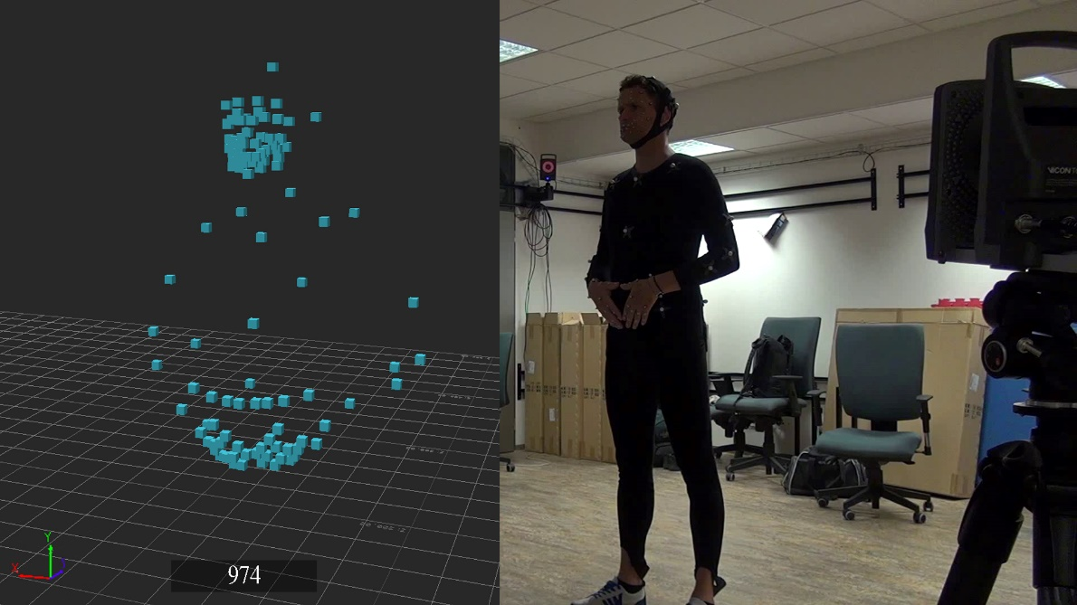The input data is a sequence of isolated lexical items. Each item is followed by a rest-pose (see Figure 11).

Figure 11: Rest-pose: on the left MoCap data; on the right - real signer during recording

The input data is direct output of a MoCap system in .c3d file format. Basically it is a “cloud” of points with labels and coordinates for each frame. The information that needs to be extracted from this file is the 3D information about markers position in each frame, the set of used labels and the frame rate at which the recording was performed.

## Marker set

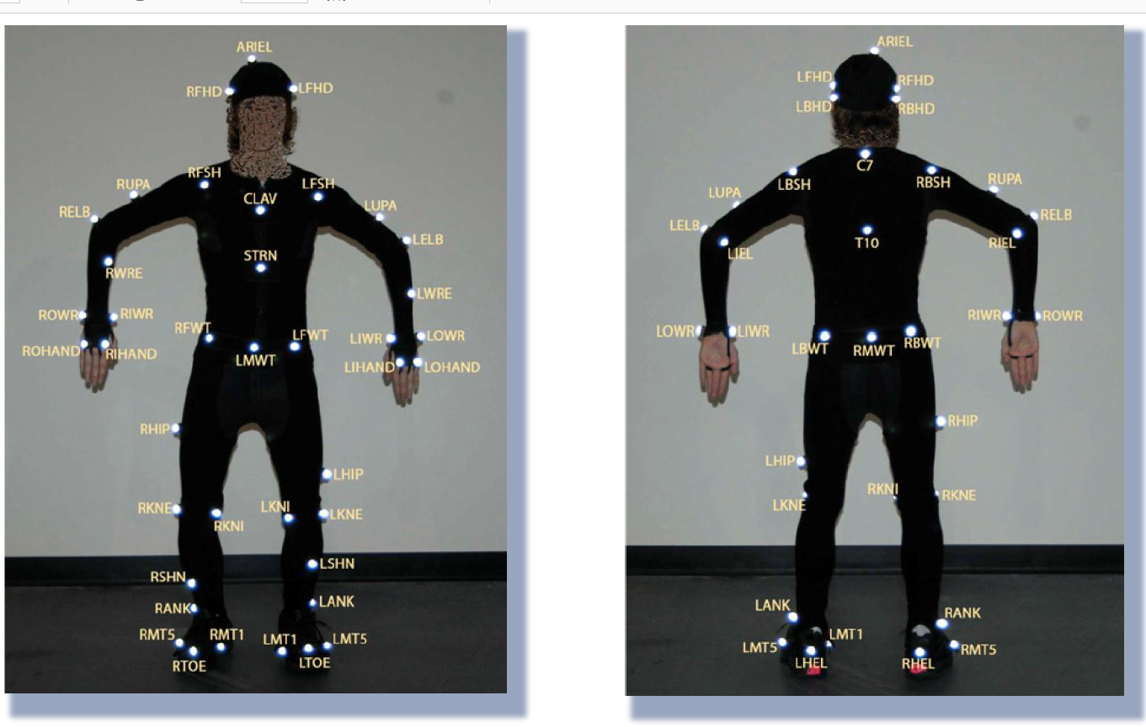The marker set consist of 109 markers over the torso, hands, fingers, head and face. The analysis is based on hand movement therefore computation are based on one artificial marker in the middle of the hand. Its position is calculated for each frame as average of the four markers on the hand:

Figure 12: Hand markers

## Segmentation // kinematics

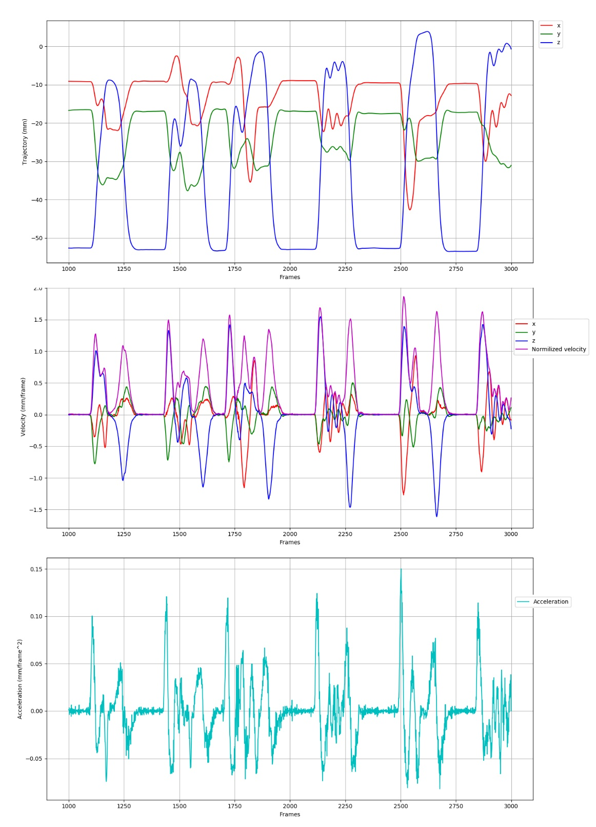Segmentation is performed in the meaning of finding start and end frames of all lexical items in a dictionary file. A common approach for motion segmentation uses kinematics features of the movement. First velocity along the three axes is calculated. It describes the change in displacement over time. Then The Frobenius norm is applied, because at that point the general movement is more interesting rather than the movement along each axis. Other kinematic feature is acceleration, which describes how the velocity changes through the period of time. Figure 13 shows graphs of this functions over time for a small sample of data.

Figure 13: Hand kinematics

The idea is to find zero-crossings points in acceleration to identify changes in velocity. But FIRST filtering

figure and explanation of markers that I’ve used

what exactly is the input data?

relative coordinate system? Why?

normalization of the velocity, why and how

how exactly segmentation is performed

## methods for segmentation and it is challenges

## problems with acceleration computation // fuzziness

## methods for filtering

## methods used for describing the properties of each sign

## SVM

# Testing

# Conclusion

# Bibliography

#### T. Hanke, “Hamnosys-representing sign language data in language resources and language processing contexts," in LREC, vol. 4, pp. 1-6, 2004.

#### Stokoe, William C. (1960, 1978), “Sign language structure: An outline of the visual communication systems of the American deaf," Studies in linguistics, Occasional papers, No. 8, Dept. of Anthropology and Linguistics, University at Buffalo. 2d ed., Silver Spring: Md: Linstok Press.

#### Mihoko Kato, “A Study of Notation and Sign Writing Systems for the Deaf ", Intercultural Communication Studies XVII: 4 2008, Toyohashi University of Technology

#### J. McDonald, R. Wolfe, R. B. Wilbur, R. Moncrief, E. Malaia, S. Fujimoto, S. Baowidan, and J. Stec, “A new tool to facilitate prosodic analysis of motion capture data and a data- driven technique for the improvement of avatar motion," 2016.

#### E. Muybridge, “Muybridge's Complete Human and Animal Locomotion”. Collections of ne art in Dover books, Dover Publications, 1979

#### “Go Further with Vicon MX T-Series” Vicon Motion System Limited, rev. 1.3 August, 2010

#### N. Wheatland, Y. Wang, H. Song, M. Neff, V. Zordan, and S. Jörg, “State of the art in hand and finger modeling and animation” Computer Graphics Forum, vol. 34, no. 2, pp. 735–760, 2015

#### M. Dilsizian, Z. Tang, D. Metaxas, M. Huenerfauth, and C. Neidle, “The importance of 3D motion trajectories for computer-based sign recognition" 7th Workshop on the Representation and Processing of Sign Languages: Corpus Mining, The 10th International Conference on Language Resources and Evaluation (LREC 2016), 2016.

#### T. Hanke, S. Matthes, A. Regen, and S. Worseck, “Where does a sign start and end? segmentation of continuous signing" 5th Workshop on the Representation and Processing of Sign Languages: Interactions between Corpus and Lexicon, Language Resources and Evaluation (LREC 2012), 05 2012.

#### Perlmutter, David M., "What is Sign Language?"LSA, 12 April 2014. Retrieved 4 November 2013.

#### Sandler, Wendy; & Lillo-Martin, Diane., “Sign Language and Linguistic Universals” , 2006. Cambridge: Cambridge University Press.

#### P. Jedli_cka, Z. Kr_noul, and M. _Zelezn_y, “Methods for recognizing interesting events within sign language motion capture data” in Universal Access in Human-Computer Interaction. Designing Novel Interactions (M. Antona and C. Stephanidis, eds.), (Cham), pp. 55-75, Springer International Publishing, 2017.

#### L. Naert, C. Larboulette, and S. Gibet, “Coarticulation analysis for sign language synthesis” in 7th Workshop on the Representation and Processing of Sign Languages, LREC, 2016.

#### [Python documentation](https://docs.python.org/3/library/index.html) - https://docs.python.org/3/library/index.html

#### “The C3D file format”, MotionLab Systems, Inc., 2002